

Evolution of Industrial Revolution 4.0 in seaport system: an interpretation from a bibliometric analysis (TITLE 14 PT, Arial MT)

Jagan Jeevan a, Mahendran Selvaduraya, Nurul Haqimin Mohd Salleh a,

Abdul Hafaz Ngah b and Suhaiza Zailanic

aFaculty of Maritime Studies, Universiti Malaysia Terengganu, Kuala Nerus, Malaysia; bFaculty of Business, Economics and Social Development, Universiti Malaysia Terengganu, Kuala Nerus, Malaysia; cFaculty of Business and Accountancy, Universiti Malaya, Kuala Lumpur, Malaysia

# ABSTRACT (Arial, 8pt)

# A single paragraph of about 100 words to give a brief introduction to your work.

# Keywords: keywords 1; keywords 2; keywords 3 (List three to six pertinent keywords specific to the article yet reasonably common within the subject discipline.)

# 1.Introduction (Arial, 10pt)

Seaport inefficiencies have triggered obstacles on its operations especially on maritime disruption which eventually contributes to high-cost expenses, unnecessary waste and environmental pollution, and capital losses (Salleh, Abd Rasidi, and Jeevan 2020). It is believed that the emergence of new technology has become a decisive determinant to overcome these issues. Digital transformation is a key component in the industrial trans- formation which has led to IR 4.0. The physical world has been connected to the digital world through the technological transformations since 2011 and become a global catch- phrase especially among the industrialists (Mudin et al. 2018).

# 1.1 Subheading (Arial, 10pt)

This is the sample of your paper. The major headings should be centered in column. Use capital letters with font size 10pt. Subheadings should be aligned to the left-hand margin of the column on a separate line. Use single spacing, 10pt Arial throughout the paper.

Proceedings GLOCOMS 2024 https://fpm.umt.edu.my/research/conference/

1. Literature Review (Arial, 10pt)
2. Methodology (Arial, 10pt)
3. Results and discussion (Arial, 10pt)

5. Conclusion and implication (Arial, 10pt)

# Disclosure statement

The statements, opinions and data contained in all publications are solely those of the individual author(s) and contributor(s)

# Funding

# Notes on contributors

*Jagan Jeevan*,

*Mahendran Selvaduray*

*Nurul Haqimin Mohd Salleh*,

*Abdul Hafaz Ngah*

*Suhaiza Zailani*

# ORCID

*Jagan Jeevan * <http://orcid.org/0000-0002-0625-5018>

*Nurul Haqimin Mohd Salleh * <http://orcid.org/0000-0001-6187-8624>

*Abdul Hafaz Ngah * <http://orcid.org/0000-0002-9928-1708>

Table 1. Search string strategies.

No Keyword search in Scopus Articles

|  |  |  |
| --- | --- | --- |
| 1. | ‘Industrial Revolution 4.0’ AND ‘seaport’ | 4 |
| 2. | ‘Industrie 4.0’ AND ‘seaport’ | 7 |
| 3. | ‘fourth industrial revolution’ AND ‘seaport’ | 7 |
| 4. | ‘fourth revolution’ AND ‘seaport’ | 3 |
| 5. | ‘industry 4.0’ AND ‘seaport’ | 50 |
| 6. | ‘new Industrial Revolution’ AND ‘seaport’ | 2 |
| 7. | ‘fourth industrial’ AND ‘seaport’ | 6 |
|  | *Total* | 79 |
|  | *After remove duplicate* ﬁ*les* | 59 |
| Source: Authors. |  |  |

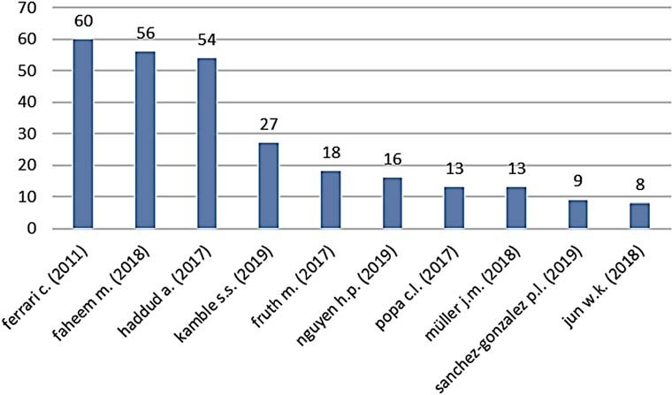

Figure 1. Frequency distribution of top 10 cited articles from Scopus. Source: Authors.

# References

ABB. 2020. “ABB to Bring Autonomous Technology to the Port of Singapore” [https://new.abb.com/](https://new.abb.com/news/detail/39090/abb-to-bring-autonomous-technology-to-the-port-of-singapore) [news/detail/39090/abb-to-bring-autonomous-technology-to-the-port-of-singapore.](https://new.abb.com/news/detail/39090/abb-to-bring-autonomous-technology-to-the-port-of-singapore)

Alaba, F., M. Othman, I. Hashem, and F. Alotaibi. 2017. “Internet of Things Security: A Survey.” *Journal* *of Network & Computer Applications* 88 (C): 10–28.

Bandyopadhyay, D., and J. Sen. 2011. “Internet of Things: Applications and Challenges in Technology and Standardization.” *Wireless Personal Communications* 58 (1): 49–69.

Baştuğ, S., G. Arabelen, C. A. Vural, and D. A. Deveci. 2020. “A Value Chain Analysis of a Aeaport from the Perspective of Industry 4.0.” International Journal of Shipping and Transport Logistics 12 (4): 367–397.

Bedekar, A. 2017. “Opportunities & Challenges for IoT in India” [Online]. Accessed 12 October 2017. [http://www.startupcity.com/leaders-talk/-opportunitieschallenges-for-iot-in-india-nid-3444.html.](http://www.startupcity.com/leaders-talk/-opportunitieschallenges-for-iot-in-india-nid-3444.html)

Berthold, K. 2017. “The ‘Ghost Port’ of Qingdao is Starting Operations.” *logistic aktuell.* [https://](https://logistik-aktuell.com/2017/12/15/ghost-port-qingdao-starting-operations/) [logistik-aktuell.com/2017/12/15/ghost-port-qingdao-starting-operations/.](https://logistik-aktuell.com/2017/12/15/ghost-port-qingdao-starting-operations/)

Carlan, V., C. Sys, and T. Vanelslander. 2016. “How Port Community Systems Can Contribute to Port Competitiveness: Developing a Cost–Beneﬁt Framework.” *Research in Transportation Business &* *Management* 19: 51–64.

Chen, S. L., Y. Y. Chen, and C. Hsu. 2014. “A New Approach to Integrate Internet-of-Things and Software-as-a-Service Model for Logistic Systems: a Case Study.” *Sensors* 14 (4): 6144–6164.

Cho, H. S., J. S. Lee, and H. C. Moon. 2018. “Maritime Risk in Seaport Operation: A Cross-Country Empirical Analysis with Theoretical Foundations.” *Asian Journal of Shipping and Logistics* 34 (3): 240–248.

Da Xu, L., W. He, and S. Li. 2014. “Internet of Things in Industries: A Survey.” *IEEE Transactions on* *Industrial Informatics* 10 (4): 2233–2243.

Decker, C., M. Berchtold, L. W. F. Chaves, M. Beigl, D. Roehr, T. Riedel, M. Beuster, T. Herzog, and D. Herzig. 2008. “Cost-Beneﬁt Model for Smart Items in the Supply Chain.” In *The Internet of Things*, 155–172. Berlin, Heidelberg: Springer.